**Assignment 2**

**Problem Statement:**

You work for a corporation and the current requirement in the organization is for faster file sharing, which can also help in data replication from on-premises infrastructure.

**Tasks To Be Performed:**

1. Create an FSX file system for a Windows file server:

a. Make sure you have AWS Managed Active Directory with a valid domain name

b. Connect it to your Windows EC2 server

2. Create an FSX file system for Lustre and attach it to an Amazon Linux 2 instance.

**Solution:**

Step 1: - Lets create an Active Directory with a domain for the FSx system.

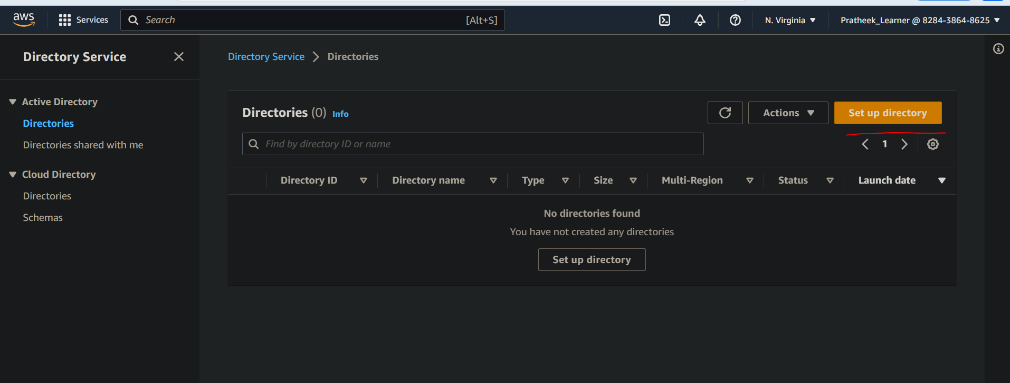

There are many types of directory types. Select AWS managed Microsoft AD.

In the directory DNS name, provide any name to as it is to store your credentials (AD).

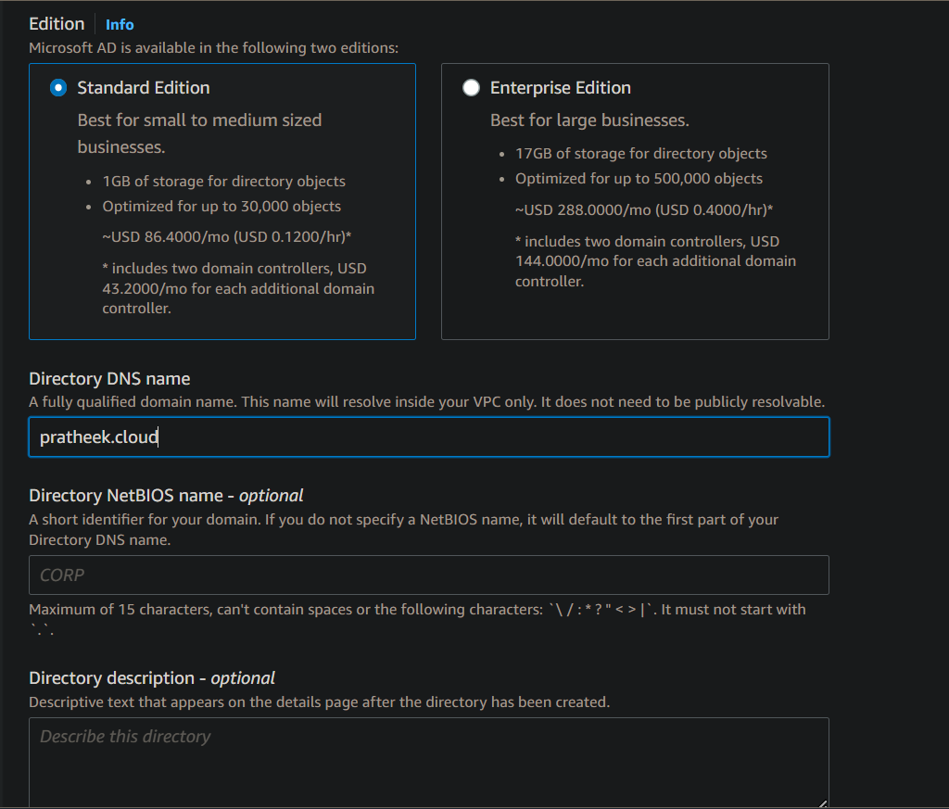

In the next stage, select your preferred VPCs & subnets.

Finally Review the AD. The creation can take Upto 20-45 mins. Also this AD service doesn’t come under free tier.

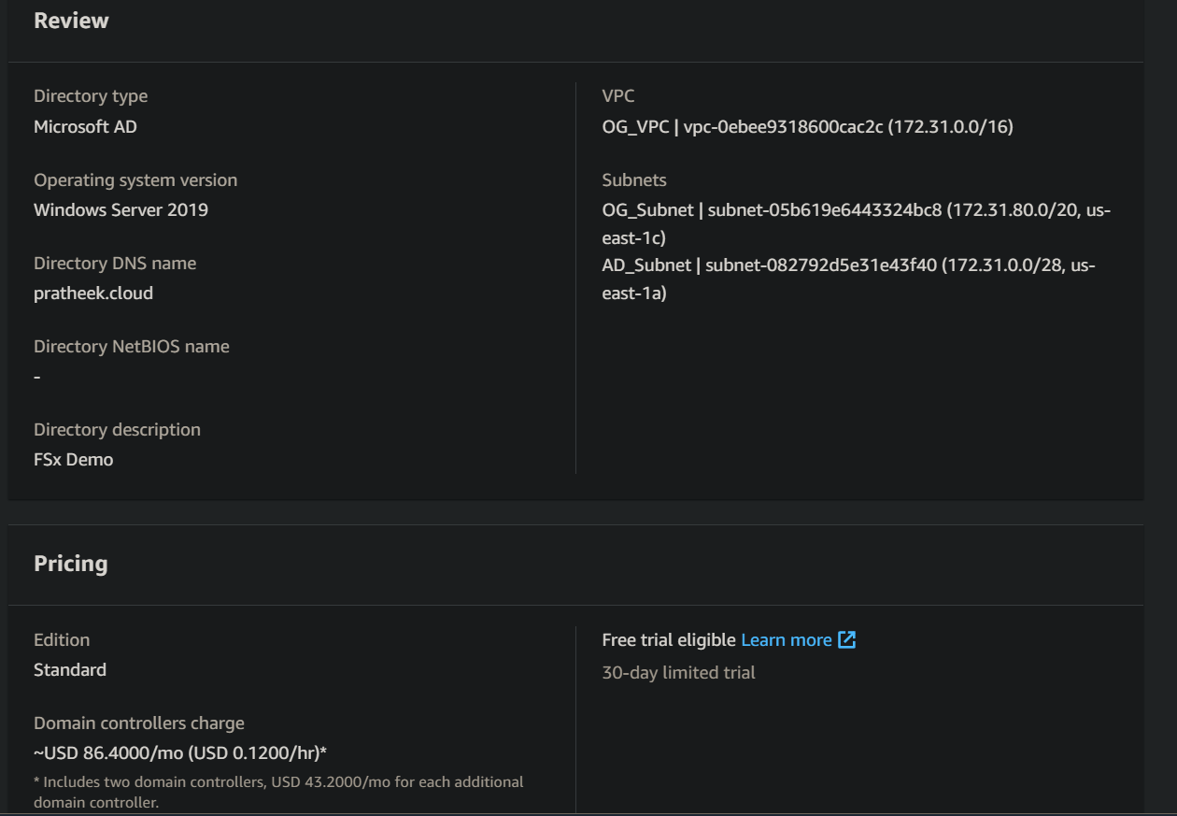

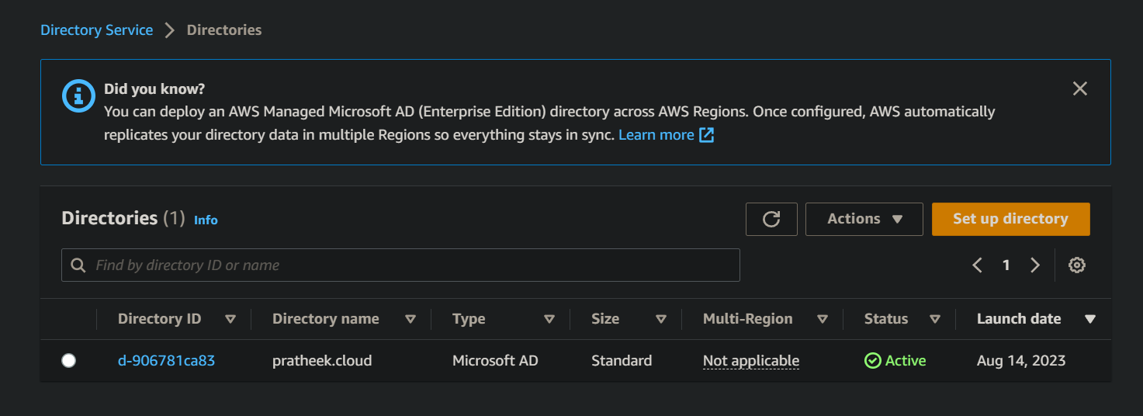

Step 2: Create FSx system. This can be done only after AD is created. Select Windows File server in FSx for windows ec2 instance.

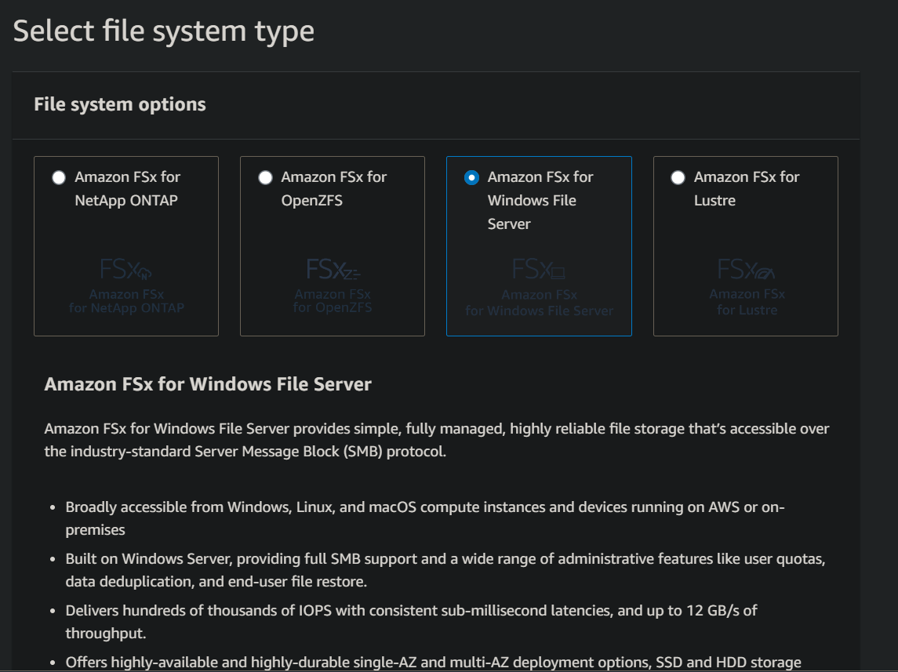

Then specify the file system details in the next page.

In the Windows authentication option, chose AWS managed AD & select the one created.

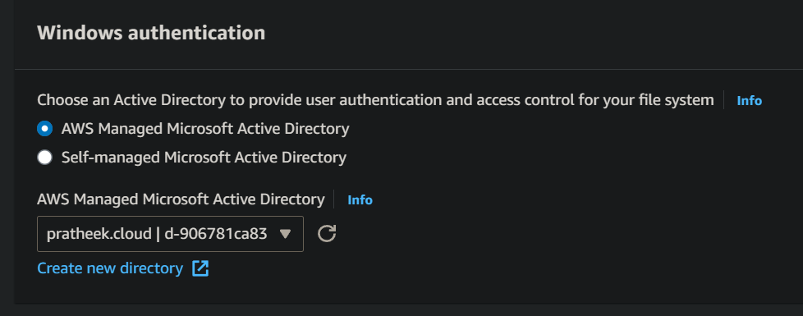

Then create the FSx after reviewing. FSx takes time to create.

Step 3: We have to associate server (Windows EC2) with AD. Create a Windows EC2 server. In that EC2 go to control panel of your Windows EC2 server & go to Network and internet -> view network status.

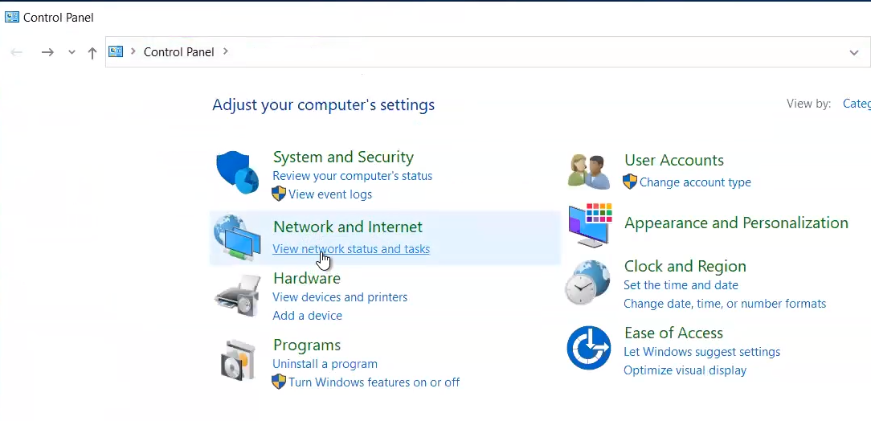

Then go to ethernet.

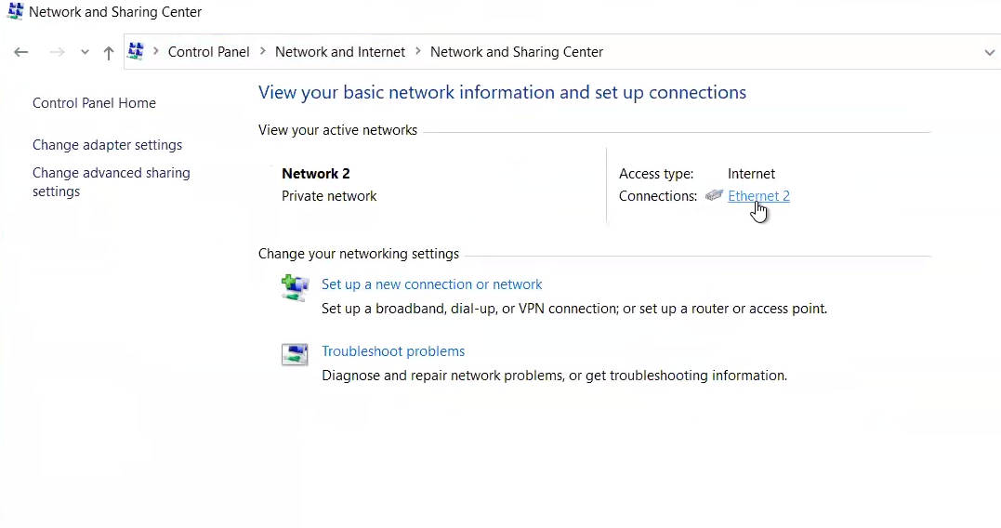

Edit the properties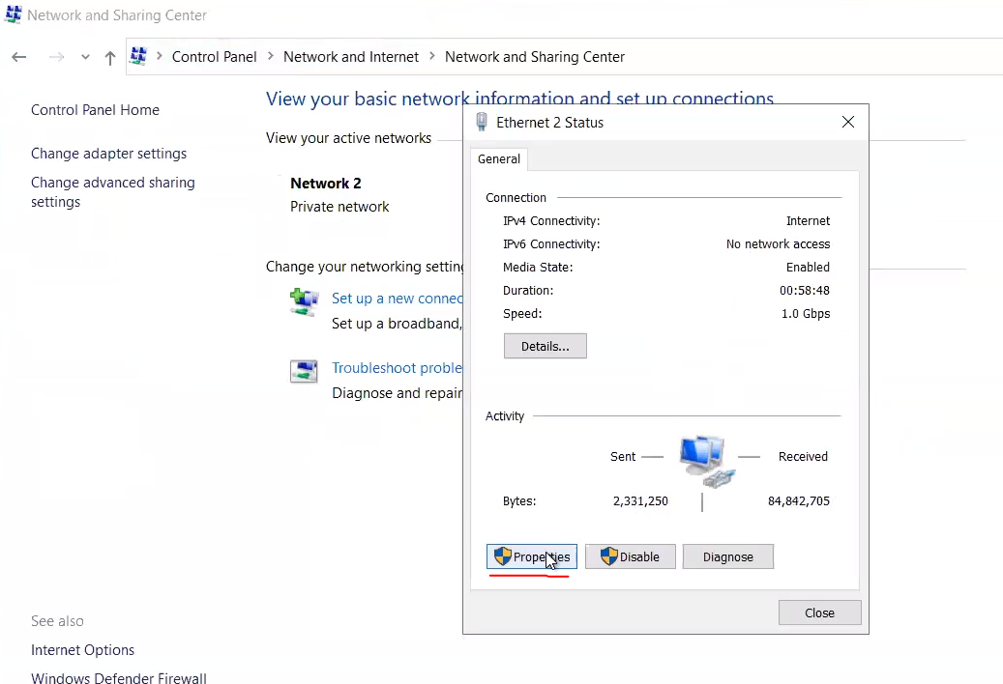

Select IPv4 & go to properties,

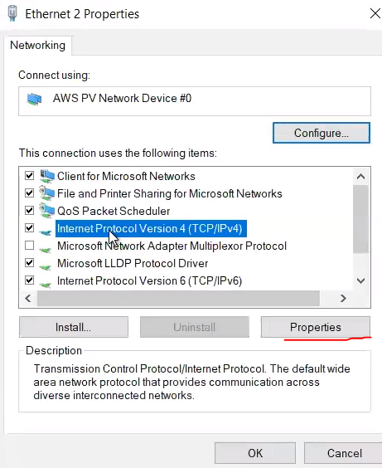

Select the highlighted options.

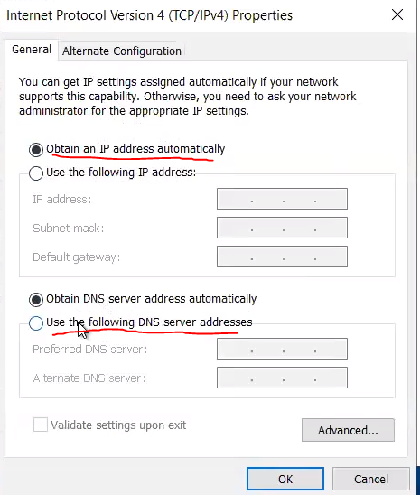

To fill the 2 DNS servers addresses, go to AD in AWS & copy the DNS addresses from there

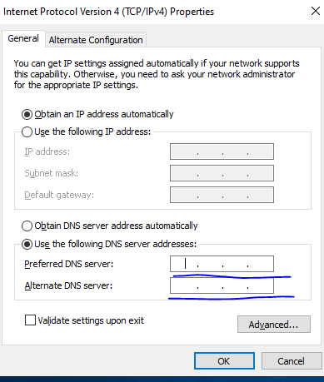

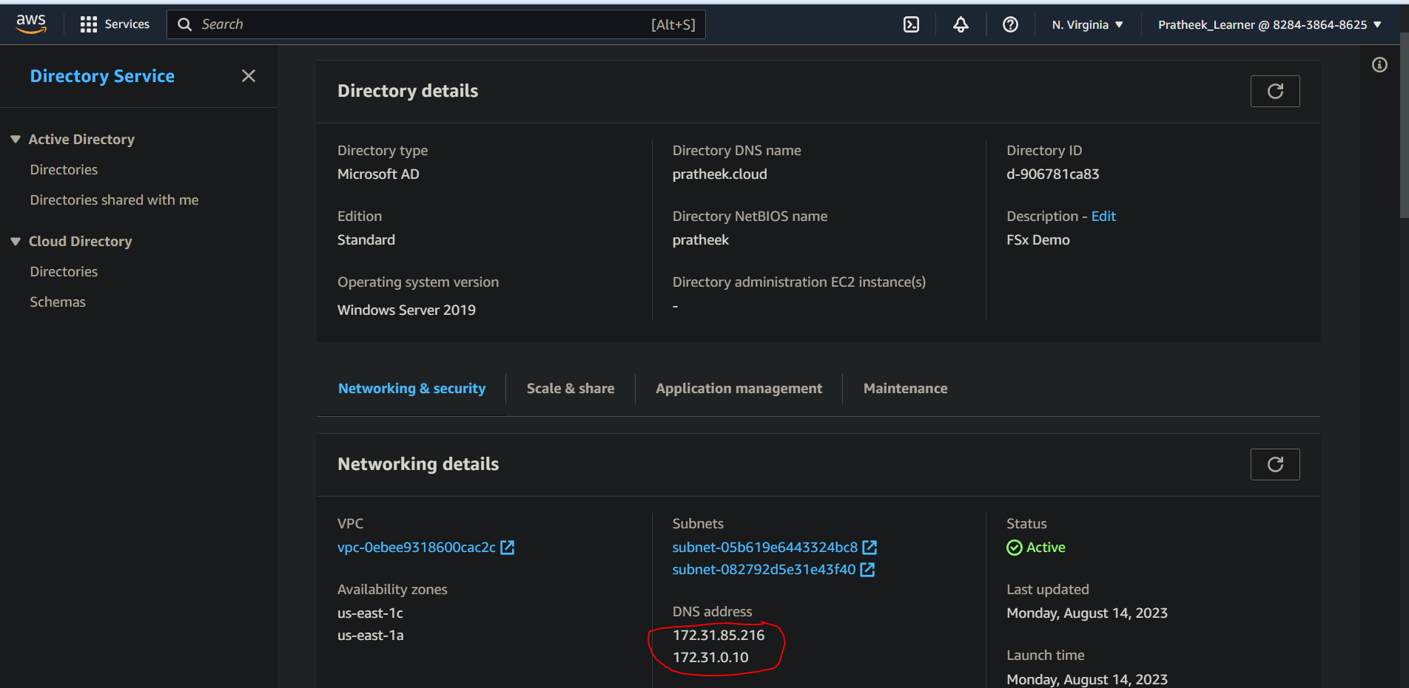

Once filled, close it.

Now we have to configure the domain. Go to advance system settings -> computer name -> Change

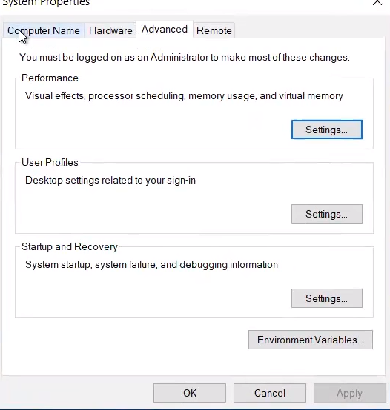

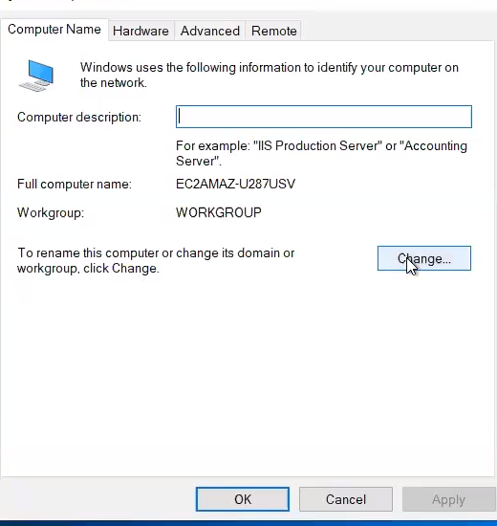

Fill the domain with the AD domain name

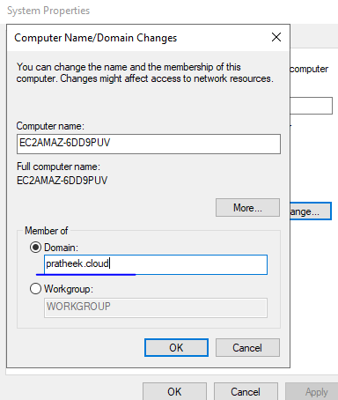

Clicking to ok you will be prompted for Username & password. Fill with the ones that you have provided while creating the AWS AD. Then the AD will be changed to our AD. The procedure of AD is completed.

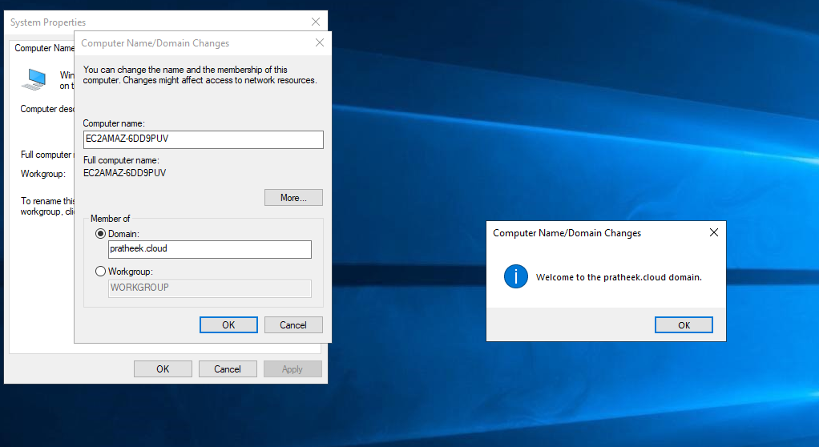

Now we have to mount the FSx to the Windows System. Now go to FSx system in AWS, select attach & copy the command.

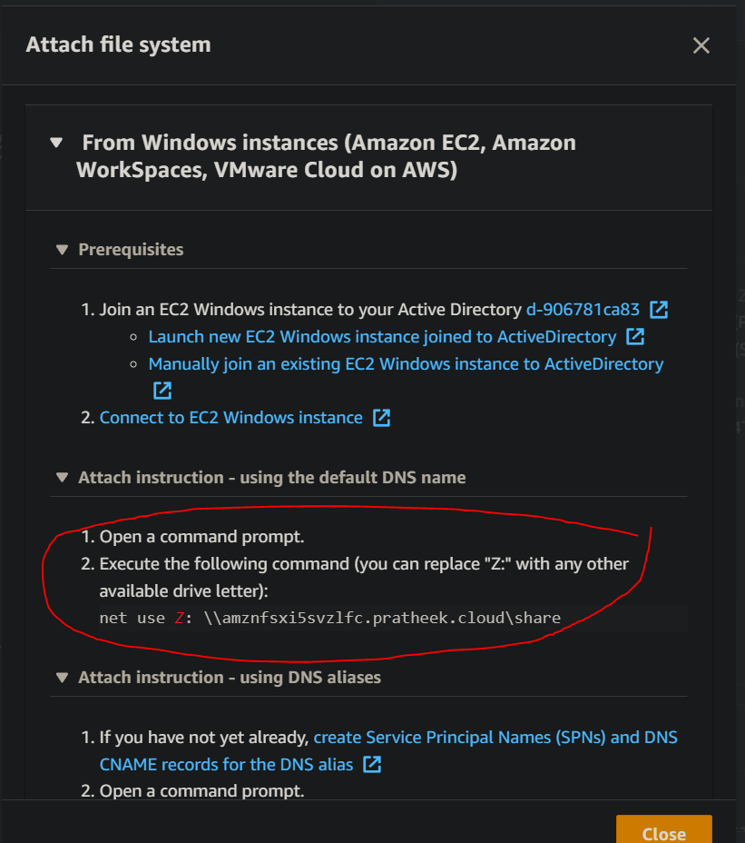

Now paste the command into the command prompt of the Windows-EC2 server.

(Side-Note :- You may see this Network 53 error when the storage gateway is not allowing all the three required NFSv3 ports. I would suggest verifying the gateway EC2 instance **security group** and check if it has **allowed ports 20048, 111 and 2049** in its Inbound rules from the client IP address that you are trying to mount. Or you can have all traffic enabled in Security group & bypass this issue, though in production that is not recommended & you enable only the required ports at the required time. If all else fails, fully delete the FSx & Then the AD, & recreated the AD and FSx. Painful but in this way it worked for me).

Error 53:

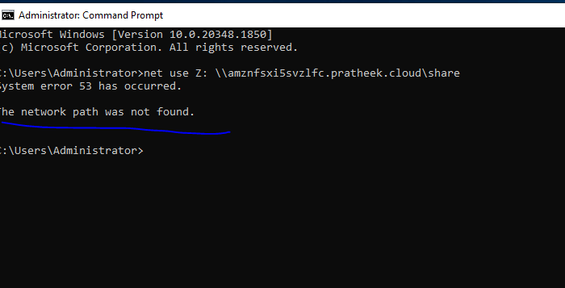

Now the actual command paste:

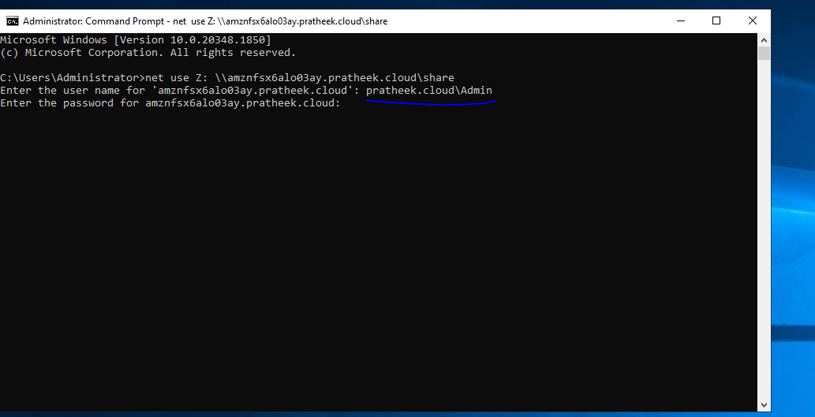

In the username, put your “domain\username”. Then enter the password.

Before:

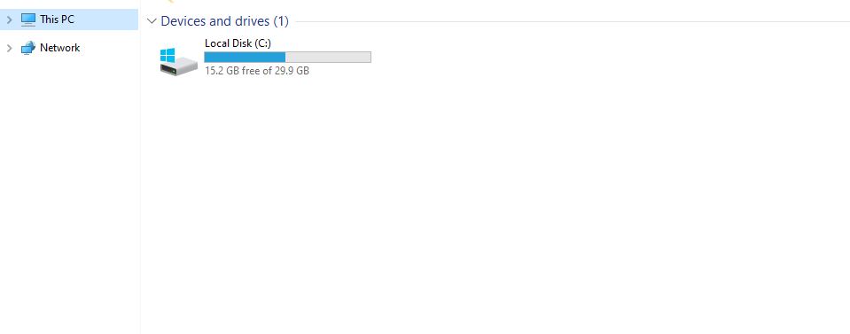

After the password:

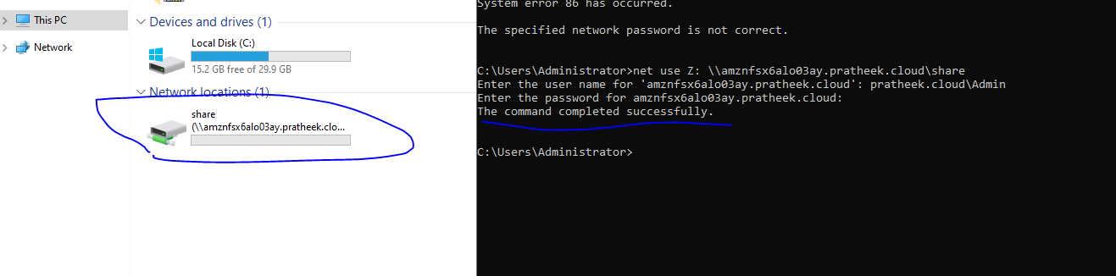

The Shared FSx system is now successfully mounted to the Windows system.

Step 4:- Now to mount FSx to Linux system using FSx Lustre.

Go to the FSx & this time create FSx under Lustre

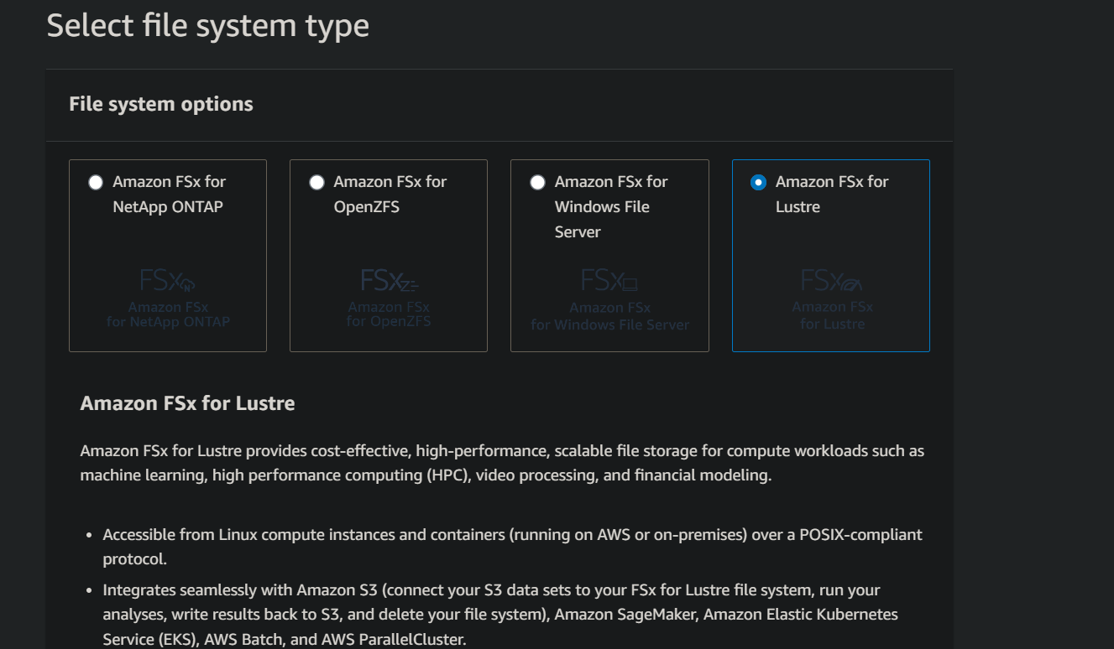

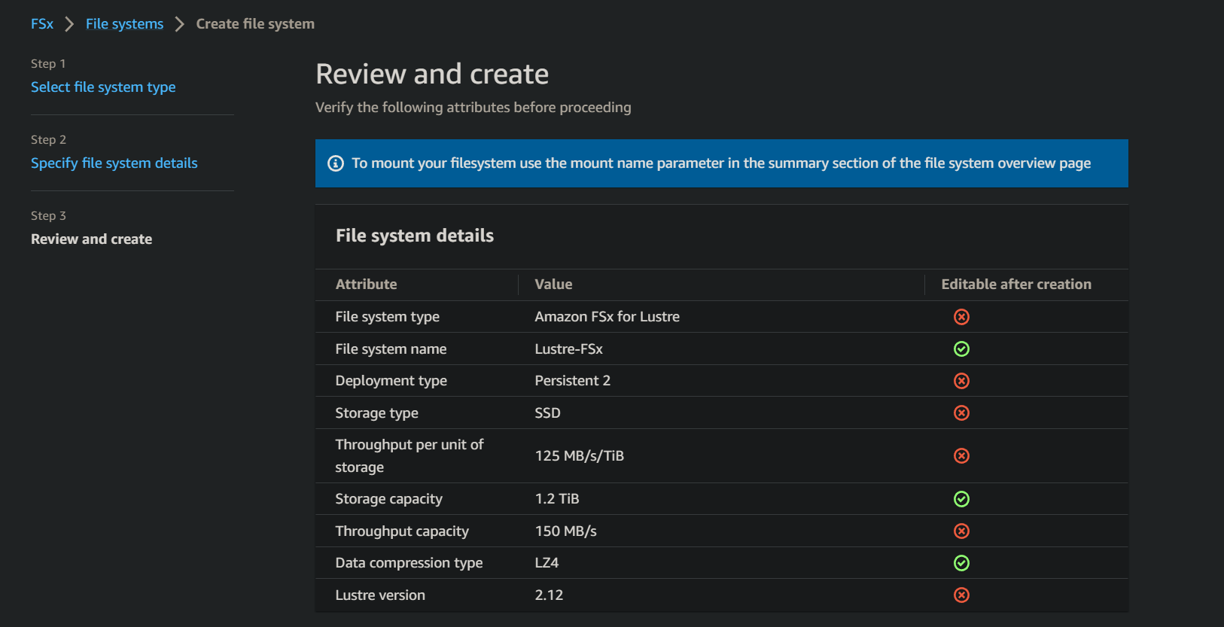

Now you have to launch Amazon Linux EC2 for this to work. Use AMI - Amazon Linux 2 for the following command to work. Then install lustre client in the ec2 instance.

Command :- sudo amazon-linux-extras install lustre -y

Then go to the Lustre FSx & click on attach & copy the commands to the linux ec2.

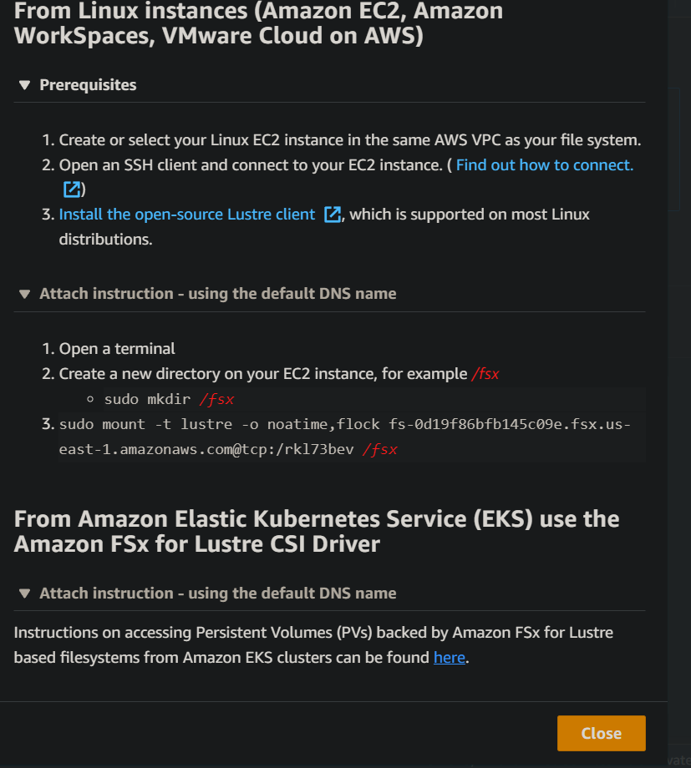

FSx lustre for linux is successfully mounted.

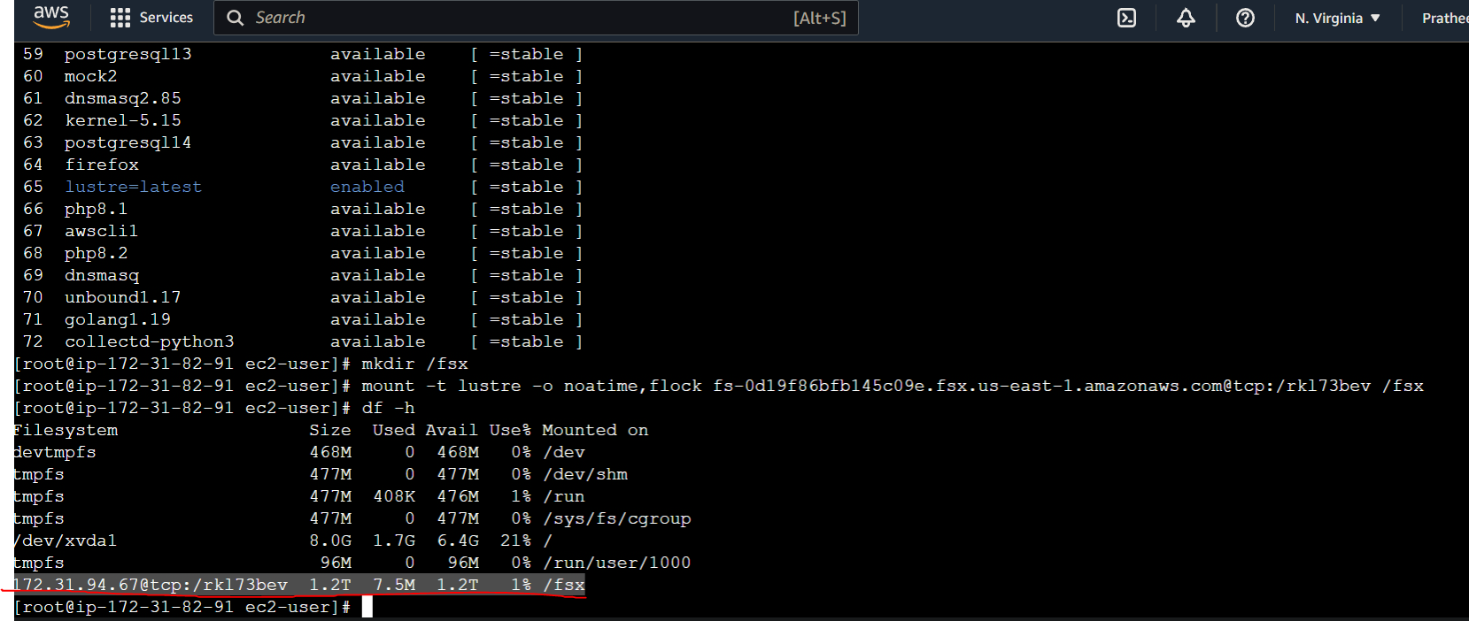

Note – Cleanup all the resources post completion so as to avoid further charges.